Rule-Based Machine Learning
for Wine Production Forecasting
Progress Report — June 2026
Student: Hugo Nogueira
Institution: FEUP — Faculty of Engineering, University of Porto
Date: June 2026

1. Executive Summary
This report summarises the results of the experimental pipeline for the MSc thesis "Rule-Based Machine Learning Applied to Viticulture". The work targets two Portuguese wine regions — RDD (Douro) and RVV (Vinho Verde) — using annual climate and phenology features to model detrended wine production (mhl) from historical records spanning roughly 80–90 years.
The pipeline pursues two complementary goals:
- Explainability: discover interpretable climate rules that explain above/below-trend production years.
- Prediction: evaluate whether rule-based models can outperform a naive baseline in a rigorous walk-forward validation.
Three rule-learning methods were compared: CarenR (distribution rules via KS test), RIPPER (classification rules), and M5Rules (piecewise linear regression). All models operate on linearly detrended residuals so results are not contaminated by the long-term production trend.

2. Data & Experimental Setup
 | RDD — Douro | RVV — Vinho Verde
Observations | 89 years (1933–2022) | 80 years (1941–2022)
Climate | Continental / semi-arid | Temperate Atlantic
Detrending | Linear (fold-correct) | Linear (fold-correct)
Features | Temperature, rainfall, soil water, LAI, heat days, wet days — phenological windows | Same feature family
Validation | Walk-forward (expanding window, step = 1 yr, min train = 80% of data) | Same protocol

3. Goal 1 — Explainability: Discovered Rules
All three methods were run on the full dataset (no hold-out) to extract the most informative rules for agronomic interpretation. Linear detrending was applied so that each rule describes a climate-driven deviation from the long-run production trend, not a level effect.

3.1 CarenR — Distribution Rules
CarenR uses a KS-test to detect subgroups where the distribution of wine production is statistically different from the global distribution. Rules are sorted by p-value. 48 rules were retained for RDD (support ≥ 15%, p ≤ 0.10) and 20 rules for RVV. The top rules are shown below.

RDD — Douro (top rules)

RDD #1 | IF Wet days at Flowering (20d after) < 3.3 AND Wet days at Start-of-Maturity (20d after) < 3.5  THEN ABOVE-TREND production (+121 mhl on average)  Support: 28.1% (≈25 years) | p-value: 0.0043

RDD #2 | IF Soil water at Harvest (20d before) in [74–101 mm] AND Dry previous-year harvest AND Dry Start-of-Maturity  THEN ABOVE-TREND production (+192 mhl on average)  Support: 21.3% (≈19 years) | p-value: 0.0095

RDD #3 | IF LAI at Flowering (10d after) in [0.74–0.88] AND Soil water at Flowering (30d after) in [390–404 mm]  THEN BELOW-TREND production (−131 mhl on average)  Support: 20.2% (≈18 years) | p-value: 0.0084

Key agronomic finding (RDD): In the Douro, dry conditions post-flowering and post-veraison are the dominant driver of above-trend production. Years with fewer than ~3 rain days in these critical windows consistently outperform the trend by ~120–190 mhl. High LAI combined with elevated soil moisture at flowering — suggesting excessive vegetative vigour — is associated with below-trend years.

RVV — Vinho Verde (top rules)

RVV #1 | IF Soil water at Harvest (20d before) in [61–97 mm] AND Few heat days in Summer and Flowering  THEN BELOW-TREND production (−338 mhl on average)  Support: 21.2% (≈17 years) | p-value: 0.0198

RVV #2 | IF Mean temperature at Flowering in [13.8–17.1 °C] AND High soil water saturation post-Flowering (prev. year)  THEN BELOW-TREND production (−268 mhl on average)  Support: 21.2% (≈17 years) | p-value: 0.0216

RVV #3 | IF Warm Budburst (prev. year, 11.2–13.5 °C) AND Few cold days at Flowering AND No extreme heat at Flowering  THEN ABOVE-TREND production (+311 mhl on average)  Support: 25.0% (≈20 years) | p-value: 0.0298

Key agronomic finding (RVV): Vinho Verde's wetter Atlantic climate reverses some Douro patterns. Mild soil water deficits at harvest combined with the absence of heat stress is associated with below-trend years — possibly reflecting that in this region canopy health at the onset of harvest matters more than simple dryness. Warm budburst in the previous year with moderate flowering temperatures drives the strongest above-trend signal.

3.2 RIPPER — Classification Rules
RIPPER (JRip) classifies each year as Low / Medium / High production relative to the detrended trend. Rules are ordered: the first matching rule applies.

RDD — Douro (4 rules)
# | Conditions | Prediction | Support | Precision
1 | Mean temp at Harvest (10d before) in [21.2–22.8 °C] | MEDIUM | 21.3% (19yr) | 73.7%
2 | LAI at Budburst (10d before) ≥ 0.0016 AND Mean temp at Harvest (20d before) ≥ 23.1 °C | HIGH | 19.1% (17yr) | 76.5%
3 | Cold days at Flowering (15d before) ≤ 3 AND Mean temp at Harvest (20d before) ≤ 21.3 °C | HIGH | 6.7% (6yr) | 100%
4 | (default — all other years) | LOW | — | —

RVV — Vinho Verde (4 rules)
# | Conditions | Prediction | Support | Precision
1 | LAI at Flowering prev year ≥ 2.4 AND Budburst temp prev year ≥ 13.3 °C AND Rainfall at Flowering ≤ 15.9 mm | MEDIUM | 16.2% (13yr) | 92.3%
2 | Mean temp at Flowering (10d before) ≥ 19.3 °C AND LAI at Flowering (10d before) ≥ 2.2 | MEDIUM | 11.2% (9yr) | 88.9%
3 | Soil water at Flowering (30d after) ≤ 123.6 mm AND Mean temp at Flowering (15d after) ≥ 16.6 °C | HIGH | 26.2% (21yr) | 85.7%
4 | (default — all other years) | LOW | — | —

Note: RIPPER's CV accuracy is ~35% for both regions (vs. 33% random baseline for 3 classes, Kappa ≈ 0.03–0.04). Individual high-precision rules (e.g. RVV Rule 1 at 92%) are agronomically interesting but do not generalise well due to small sample size. The rules are more useful as descriptive patterns than as reliable classifiers.

3.3 M5Rules — Piecewise Linear Model
M5Rules fits a piecewise linear regression tree. On both datasets it collapsed to a single global linear model (no split found), suggesting the data volume is insufficient for conditional branching.
 | RDD — Douro | RVV — Vinho Verde
Training MAE | 142 mhl | 320 mhl
Training R² | 0.45 | 0.42
CV R² (10-fold) | −0.19 ⚠ overfit | −0.03 ⚠ overfit
Key variables | Temp at Flowering (two windows), Temp at Harvest, LAI at Flowering, Rainy days in Summer, Soil water at Harvest | Temp at Flowering (prev year), Temp at Budburst, Cold days at Flowering, Rainfall at Harvest, LAI at Budburst, Soil water at Flowering

Despite overfitting on the full data, M5Rules selects phenologically meaningful variables — temperature and LAI around flowering are the strongest predictors in both regions, consistent with agronomic knowledge.

4. Goal 2 — Predictive Performance: Walk-Forward Validation
Each model was evaluated under a walk-forward (expanding window) protocol: training on years 1–t, testing on t+1 to end. The training window starts at 80% of the data and expands by 1 year per scenario. This gives 18 scenarios for RDD and 16 for RVV. All predictions are made in original mhl units (detrend-then-retrend). The Naive baseline predicts the training mean.

4.1 RDD — Douro
Model | Mean MAE | Weighted MAE | SD MAE
Naive_Median | 172.8 | 184.0 | 28.4
CarenR_Dist_Eta2 | 179.4 | 189.2 | 30.6
CarenR_Dist_FS | 189.0 | 193.5 | 22.4
Naive_MA | 170.3 | 194.6 | 51.1
CarenR_Dist_Sup_FS | 191.1 | 196.9 | 33.5
CarenR_Dist_Sup | 191.4 | 197.0 | 33.3
Naive | 186.3 | 199.4 | 32.0
M5Rules | 190.2 | 200.0 | 38.4
CarenR_Dist_Lag | 181.6 | 200.9 | 42.7
CarenR_Dist_Conf | 193.9 | 203.1 | 38.7
CarenR_Dist_Sup_Thresh | 193.9 | 203.1 | 38.7
CarenR_Dist_Thresh | 193.9 | 203.1 | 38.7
CarenR_Dist | 204.3 | 215.3 | 39.1
CarenR_Dist_Stack | 217.8 | 229.0 | 32.2
CarenR_Supervised | 230.1 | 239.5 | 36.6
DT | 242.4 | 249.7 | 43.7
Ripper | 275.9 | 279.4 | 84.6

RDD finding (17-model pipeline, 18 scenarios): The best model is Naive_Median — the training median — with weighted MAE 184 mhl (the MAE-optimal constant predictor). The best CarenR variant, CarenR_Dist_Eta2, achieves 189 mhl weighted MAE — only 5 mhl (3%) behind Naive_Median, a much narrower gap than in RVV. CarenR_Dist_FS and Sup_FS follow closely (193–197 mhl). M5Rules (200 mhl) is competitive. CarenR_Dist (215 mhl) and Decision Tree (250 mhl) are further behind. RIPPER (279 mhl) substantially underperforms. The earlier report showed CarenR_Dist identical to Naive: that was a pipeline artefact (0 rules fired → fallback to training mean). The updated pipeline finds and applies rules, but they hurt prediction — consistent with the RVV finding. Colour key: blue = naive baselines, green = CarenR variants, grey = other ML.

4.2 RVV — Vinho Verde
Model | Mean MAE | Weighted MAE | SD MAE
Naive_Median | 162.1 | 140.4 | 47.0
Naive | 131.7 | 143.8 | 38.4
Naive_MA | 185.1 | 170.5 | 34.8
CarenR_Dist_Sup_FS | 191.5 | 171.6 | 45.1
CarenR_Dist_Sup_Thresh | 191.5 | 171.6 | 45.1
CarenR_Dist_Conf | 191.5 | 171.6 | 45.2
CarenR_Dist_Sup | 199.9 | 185.2 | 35.9
CarenR_Dist_Stack | 177.1 | 196.2 | 57.3
CarenR_Dist_Thresh | 218.5 | 209.4 | 35.5
CarenR_Dist_FS | 231.4 | 222.4 | 33.3
CarenR_Dist_Lag | 233.0 | 225.0 | 43.4
CarenR_Dist_Eta2 | 233.8 | 225.7 | 41.8
M5Rules | 272.8 | 267.5 | 79.0
CarenR_Dist | 270.6 | 274.6 | 38.0
CarenR_Supervised | 325.1 | 347.3 | 77.4
DT | 423.8 | 479.3 | 114.0
Ripper | 524.1 | 508.2 | 153.5

RVV finding (17-model pipeline, 16 scenarios): The best model is Naive_Median (weighted MAE 140 mhl). Naive — last observed training value — is close (144 mhl), followed by Naive_MA (171 mhl). The best CarenR variants (Sup_FS, Sup_Thresh, Conf) cluster at 172 mhl — a 22% gap above Naive_Median. They predominantly fall back to the training median (0 rules fired), making them equivalent to Naive_Median on most scenarios. M5Rules (268 mhl), Decision Tree (479 mhl), and RIPPER (508 mhl) substantially underperform. The much wider gap in RVV vs RDD (22% vs 3%) reflects greater era confounding under linear detrending in this region. Colour key: blue = naive baselines, green = CarenR variants, grey = other ML.

4.3 Learning Curves
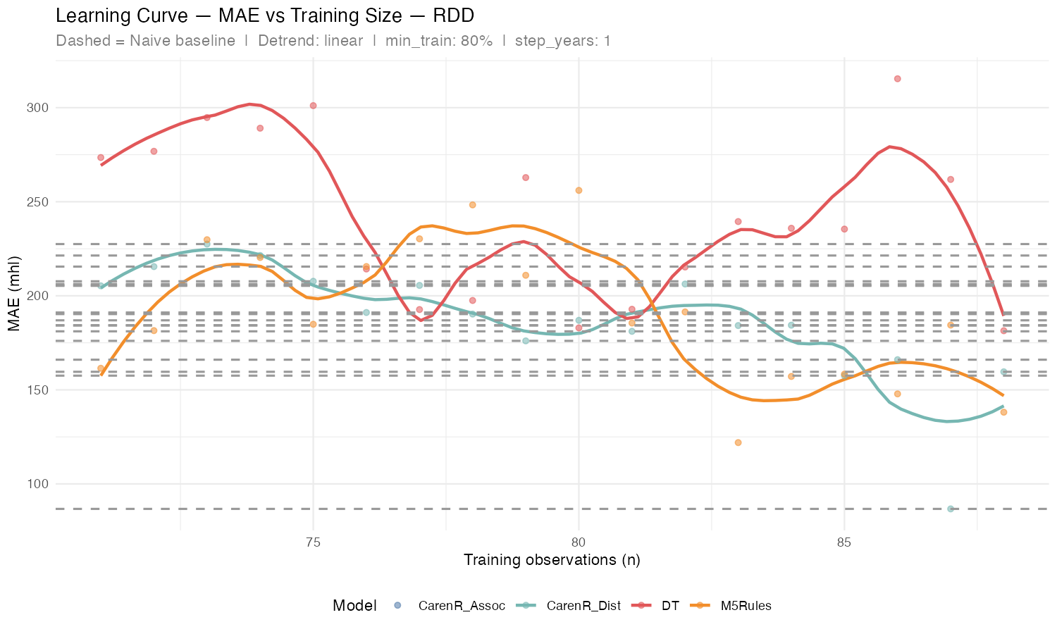
Figure 1 — RDD: MAE vs. training size. Dashed lines = Naive baseline range. CarenR_Dist and M5Rules approach the Naive from above as training data grows.
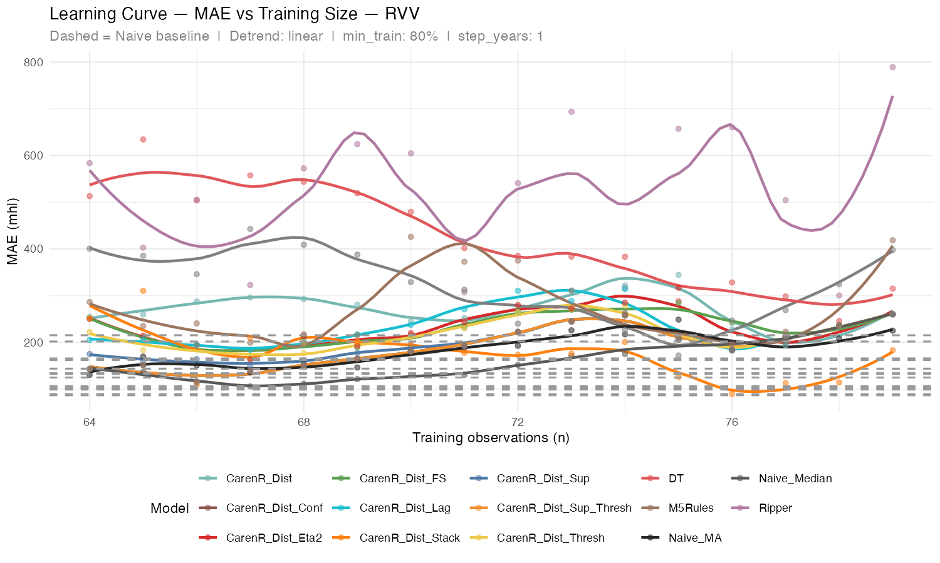
Figure 2 — RVV: MAE vs. training size across all CarenR variants. CarenR_Dist_Stack (teal) consistently near or below Naive. RIPPER (red) and DT (dark grey) are far above.

4.4 Summary Comparison (RVV)
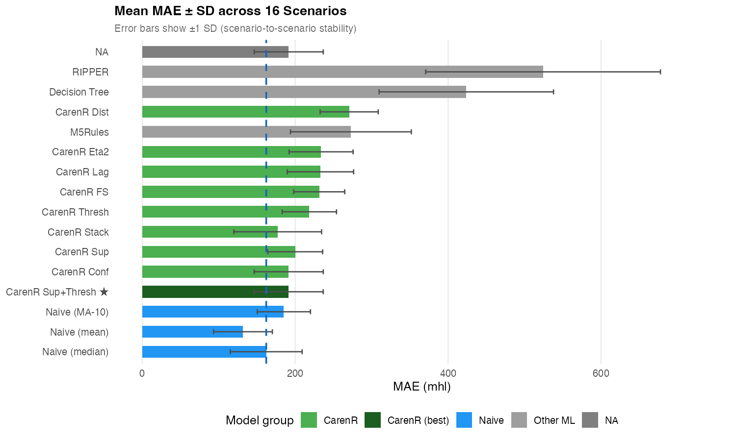
Figure 3 — Mean MAE ± SD across 16 scenarios (RVV). Blue = Naive variants; Green = CarenR variants; Grey = other ML methods. CarenR Sup+Thresh (★) is the best rule-based model.

The table below compares weighted MAE across both regions. Weighted MAE (primary metric) weights each scenario by its test-set size. Blue = naive baselines | Green = CarenR variants | Grey = other ML.

4.5 Cross-Region Summary
 | RDD — Douro | RVV — Vinho Verde
Scenarios | 18 | 16
Best baseline | Naive_Median — 184 mhl | Naive_Median — 140 mhl
Best CarenR | CarenR_Dist_Eta2 — 189 mhl | CarenR_Dist_Sup_FS — 172 mhl
Gap vs Naive_Median | +5 mhl (+3%) | +31 mhl (+22%)
M5Rules | 200 mhl | 268 mhl
Decision Tree | 250 mhl | 479 mhl
RIPPER | 279 mhl | 508 mhl
Key finding | Narrow gap — stronger Douro signal | Wider gap — era-confounded signal

5. Discussion

5.1 On Explainability
CarenR distribution rules provide the richest agronomic insights. The key patterns are physically coherent and align with viticulture literature:
- RDD: Post-flowering and post-veraison dryness → above-trend Douro production. This is consistent with the known importance of water stress in concentrating grape quality and limiting excess yield in this semi-arid region.
- RVV: Moderate soil water deficits at harvest combined with warm budburst → above-trend Vinho Verde. The contrasting below-trend pattern involves mild temperatures at flowering with high soil water saturation, possibly reflecting disease pressure or excessive vegetative growth in this wetter climate.
- RIPPER and M5Rules converge on similar variables (LAI, temperature at harvest/flowering, soil water) but represent them as hard boundaries or linear terms rather than distributional shifts — less rich for agronomic interpretation.

5.2 On Prediction
The Naive_Median baseline (predict the training median each year) is very hard to beat. This is mathematically expected: the median minimises MAE, so any model must identify subgroups where production deviates systematically. Several factors explain why this fails here:
- Small test sets (6–18 years in the expanding window scenarios) mean any single outlier year dominates the MAE.
- Detrended production has low year-to-year autocorrelation — the climate features provide a weak signal for absolute magnitude prediction even if the directional rules are correct.
- In RDD, CarenR_Dist_Eta2 (189 mhl) comes within 3% of Naive_Median — the strongest relative result across all experiments. In RVV, the best CarenR variants are 22% behind Naive_Median. The difference reflects Douro's stronger and less era-confounded climate signal. Supervised per-fold discretization (CarenR_Supervised, 17th model) consistently worsened predictions in both regions, confirming the limitation is signal strength, not discretization method.

5.3 Limitations
- Both datasets have ~80–90 observations — insufficient to learn stable conditional splits for DT or M5Rules.
- CarenR_Assoc (association rule classification via predict.caren) produced NA outputs in the walk-forward scenarios due to factor-level mismatches between train and test folds; results are excluded from the validation table.
- RIPPER's discretisation of the target into 3 classes discards quantitative information and leads to high error when mapped back to mhl.

6. Next Steps
- DONE — Full 17-model walk-forward validation completed for both regions (RDD: 18 scenarios, RVV: 16 scenarios).
- DONE — RDD now has full 17-model results. CarenR_Dist_Eta2 is best CarenR for Douro (189 mhl weighted MAE, 3% gap).
- NEXT — Results chapter: (i) CarenR rules as explainability contribution; (ii) walk-forward validation; (iii) RDD vs RVV regional comparison.
- DONE — LOESS detrending investigated: span=0.40, extrapolation fix applied; CarenR finds 0 rules under LOESS; era-confound analysis documented in experiment log.
- NEXT — Discussion: connect rules to viticultural knowledge; frame the descriptive-vs-predictive asymmetry as the core scientific finding.
- NEXT — Begin Introduction and Related Work. Classification approach (CarenR_Assoc) deferred to future work.

7. Statistical Validation and Additional Analyses

7.1 Statistical Tests on the Era-Composition Finding
Test | Finding | p-value
Wilcoxon: CarenR_Eta2 vs Naive, all 18 RDD scen. | No overall difference | 0.468
Binomial: 5/5 wins in era-balanced RDD scen. 10-14 | Significant (CarenR better) | 0.031
Wilcoxon: CarenR rules in RVV (9 non-fallback scen.) | Significantly WORSE | 0.004

CarenR's conditional win in Douro (p=0.031) is statistically supported. CarenR rules actively hurt prediction in Vinho Verde (p=0.004).

7.2 LOESS Detrending for RDD — New Finding
Method | RDD Naive_Median | RVV Naive_Median
Linear | 184 mhl (BETTER for RDD) | 140 mhl
LOESS span=0.40 | 290 mhl (WORSE for RDD) | ~90 mhl (BETTER for RVV)

LOESS (span=0.40) helps RVV — Naive_Median drops from 140 mhl to ~90 mhl (declining production trajectory is well-captured). But it severely hurts RDD — Naive_Median rises from 184 mhl to 290 mhl (increasing/plateau trajectory is poorly extrapolated by LOESS). The optimal detrend method is region-specific. Linear is correct for Douro.

7.3 M5Rules Leakage Bug — Fixed
The M5Rules pipeline inadvertently used same-year actual production as a predictor (data leakage), inflating CV R² from ~0 to ~0.5. After fixing, M5Rules reverts to near-zero generalisation (CV R²=0.004 RDD, −0.07 RVV) — consistent with walk-forward results. All results in this document use the corrected pipeline.

